

**2020 PLEXUS SGM**

**REVIEWS**

**94 points, MaryAnn Worobiec, Wine Spectator October 2023**

Complex, rich and elegant, showing notes of espresso, Kalamata olive, salted black licorice and spiced plum on a plush frame, with hints of dark chocolate. Reveals black walnut liqueur, wild blackberry and huckleberry flavors that linger on the long, peppery finish. Shiraz, Grenache and Mourvèdre.

**93 points, Huon Hooke, The Real Review, 25th February 2022.**

Very deep, red colour with a good tint of purple and a rich, ripe, typical Barossa ironstone, graphite bouquet. The wine is full-bodied and very firm, the tannins gripping the tongue and finishing long, with a fruit-sweet core and a lot of earthy, ironstone savouriness as well as fruit sweetness. A big, rich, lavishly-fruited wine, with enough tannin and structure to hold it in shape.

**92 points, Erin Larkin, Robert Parker Wine Advocate, July 2022**

Delicious. The 2020 Plexus is resinous and charry on opening—the succulent fruit starts to flower with some additional time in the glass. The 2020 season was the second of drought conditions in the Barossa and was shaped by incredibly low yields. As it happens, many of the 2020s I have tasted have been excellent quality, as this is. Concentration 101.

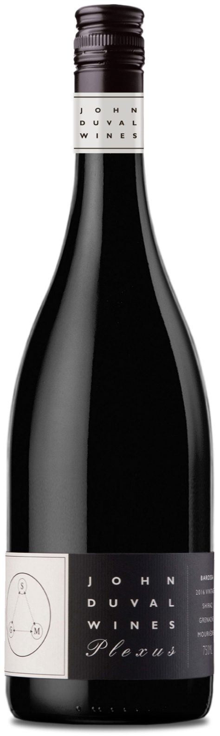



image15.png

**John Duval Wines**

PO Box 622 Tanunda, SA 5352 AUSTRALIA

**John Duval**

*Proprietor and Winemaker*

[john@johnduvalwines.com](mailto:john@johnduvalwines.com)

**Tim Duval**

*Winemaker and Sales and Marketing*

[tim@johnduvalwines.com](mailto:tim@johnduvalwines.com)

Follow us on Instagram and Facebook

**@johnduvalwines**