

**2017 ANNEXUS GRENACHE**

# REVIEWS

**95 points, Nick Butler, The Real Review, May 2019**

Medium purple colour, bright and youthful. Very fragrant - violets, red plums and oak-spice. A lovely raspberry overlay. Supple and softly red-fruited when sipped. Terrific length and structure with acidity to reward cellaring. Delicious wine.

**94 points, Mike Bennie, The Wine Front, August 2019**

Elegant thing this with a good deal of fine, suede tannin to boot. It’s highly aromatic, floral rose water and raspberry scented, shows a whiff of sweet spice, touch of green herbs. The palate is decidedly light and runs on cables of fine, dusty tannins. Length is apparent, it finishes with a flourish of gentle sweetness then clean earthiness. It’s a beauty.

**94 points, Ken Garrett, WinePilot, July 2021**

Tim offered some thoughts on grenache. “We see Grenache as a critical element to our wines, adding aromatic lift and elegance to our blends as well as spice notes complemented by a purity of fruit expression. We are lucky to have access to a range of different Grenache sites, from the sandier soils of central Barossa Valley that provide perfume and aromatic lift to the gnarly old vines from Eden Valley that show spice, more concentration and structure. This gives us a great diversity of Grenache expressions to showcase either on their own, or to add critical highlights to blended wines such as our Plexus SGM”. As usual, there were just 250 cases of this wine made. It spent 14 months in oak. The colour is pale red. For me, this is a classically varietal grenache. There is a pleasing mix of spices, red fruits, dry herbs, soft notes of beef stock and truffles. It is seamless, well structured and with silky tannins, while offering good focus. This is a very fine grenache, though for me, falls a fraction short of 2015 and 2016. It has good, not great, length. One suspects that further time in the bottle will soon fix that and it really does promise well for the future.

# image15.png

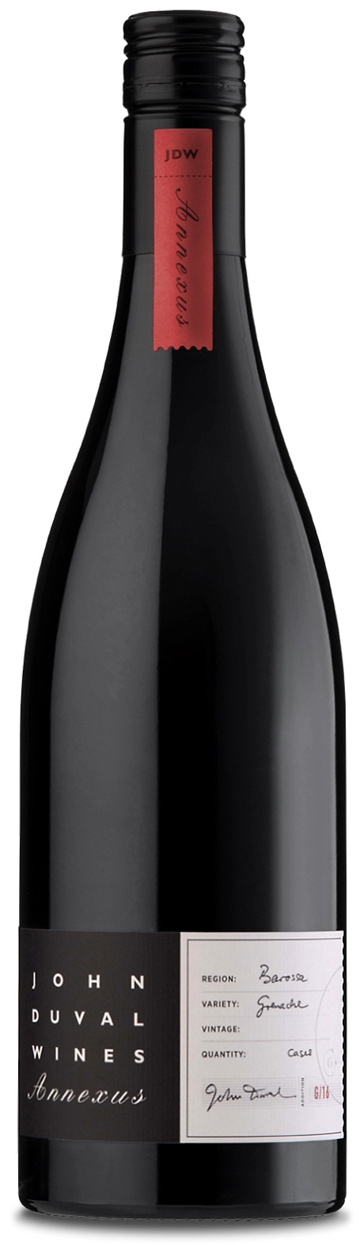



**John Duval Wines**

PO Box 622 Tanunda, SA 5352 AUSTRALIA

**John Duval**

*Proprietor and Winemaker*

[john@johnduvalwines.com](mailto:john@johnduvalwines.com)

**Tim Duval**

*Winemaker and Sales and Marketing*

[tim@johnduvalwines.com](mailto:tim@johnduvalwines.com)

Follow us on Instagram and facebook**@johnduvalwines**